Screen Form Design

**Form Mockup:**

**Using Draw.io (see Tutorial for Draw.io)**

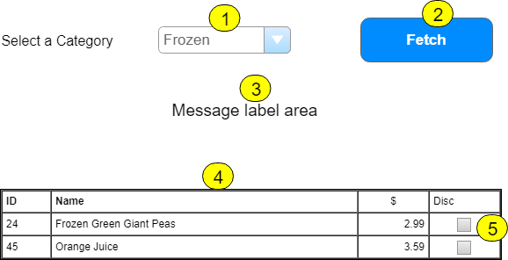

|  |  |  |  |  |  |
| --- | --- | --- | --- | --- | --- |
|  | **Control Name** | **Load/Pos** | **CRUD** | **Validation** | **Event Actions / Notes** |
| 1 | CategoryList |  | R |  | * Page_Load (!IsPostback) * BLL CategoryController * List<Category> Categories_List() * Code load in separate method * Add prompt line * Sort list |
| 2 | Fetch | 4 | R | CausesValidation F | * Requires CategoryList selection * Will fill GridView with queried data * BLL ProductController * List<Product> Products_FindByCategory(int) |
| 3 | MessageLabel | 2 |  |  | * Used to display messages * Empty in Page_Load |
| 4 | ProductList | 2 | R |  | * Customize for specific fields * Checkbox for Discontinued * Use Templates for columns * Sort data by Product Name |
| 5 | Discontinued | 2 | R |  | * Enable false |